Paper 1 Exam Practice
Lindsey Till
Aston Academy
Paper 1 Exam Practice
Brighton Rock by Graham Green
Name:

Teacher:

Target Grade:

Last mock grade:

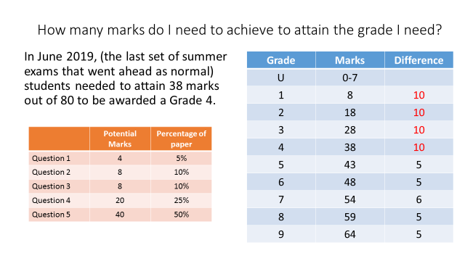

How many marks do you need to attain to achieve your target grade?

Which question do you feel you can make the most improvement on?
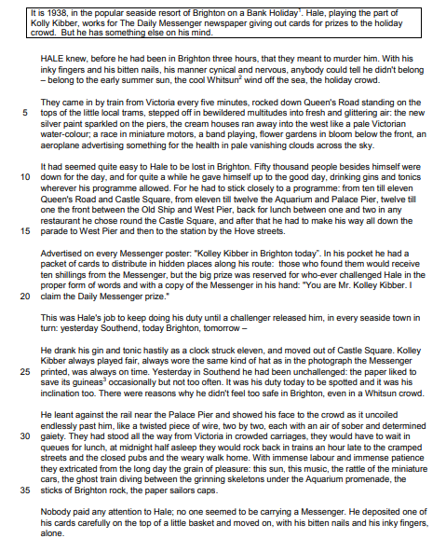
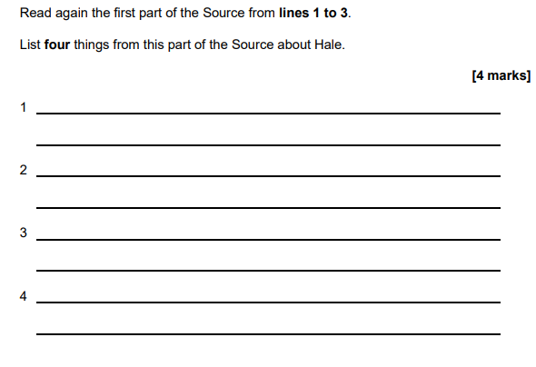

Read again lines 9-20. List four things that Hale does during his working day in Brighton.

Read lines 21-27. List four things that we learn about Hale from this section of the text.
Read lines 28 – 38. List four things you learn about the people who visit Brighton.

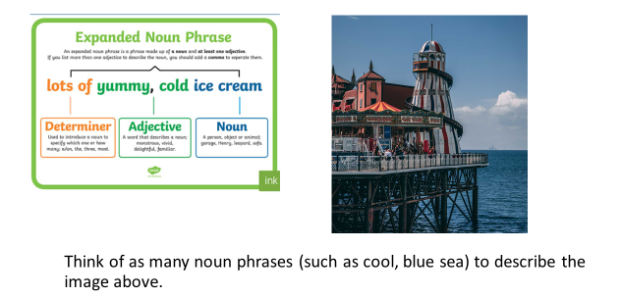
Now we are going to look at the language used by the writer to describe Brighton.
1.
2.
3.
4.
5.
6.

When we are asked to explain the language that the writer has used, we need to respond to the question by:
- using terminology in our point
- supporting this with evidence
- explaining what impression that word choice gives the reader and why the writer wanted to do that.
How many language terms can you think of?
Methods | Word Classes
Simile | Noun

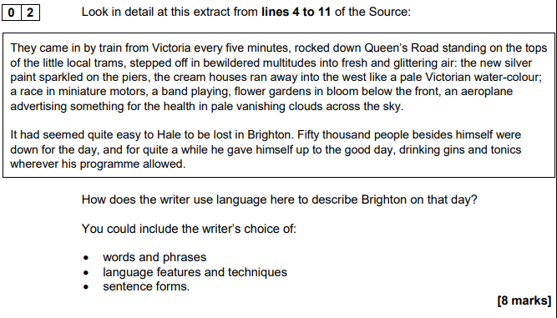
Let’s look closely at the language that the writer has used to describe Brighton.
- Underline the keywords in the question.
- Complete the table below to explain the language used by the writer to describe Brighton.
Quote | Device used | Explain how it describes Brighton | Zoom in on a word-class in the evidence – what is word class? | Explain how it describes Brighton
“The new silver paint “ | Noun phrase | The adjective ‘new’ suggests that it is a well-looked after place, which is regularly refreshed by the people who live there. | Adjective of ‘silver’ | This suggests that the place offers some sort of indulgence and luxury, as well being an attractive place to go on holiday.
“sparkled on the piers”
“fresh and glittering.”
“like a pale Victorian water-colour”

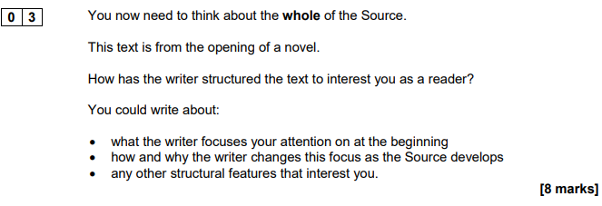
Once again, we need to include:
- A point that includes structural terminology
- Evidence copied form the text in speech marks
- An explanation of why the writer has included that structural feature there and why it interests the reader
What are structural features?
Structure means shape. So how a writer structures a text is how they shape it, or build it, to interest their readers.
See if you can make up a very quick horror story using these structural features to interest the reader:
- Pathetic fallacy
- Introduce character
- Shift focus to a threat to the character
- Shift focus to the characters thoughts
- Flashback
- Shift focus to the character’s response to the problem – use long sentences for effect
- Cyclical ending (end the story the way it began).
Every writer uses structure to interest their reader, even if they are not consciously doing it. Let’s take a look at how this extract of Brighton Rock is structured to interest the reader.
- If this extract is from the start of a novel, what would be expect the writer to be trying to do at this point?
Location in text | Text | Name of structural feature | How this interests the reader | What this focuses the reader’s attention on
Beginning | Hale knew, before he had been in Brighton three hours, that they meant to murder him. | Hook
Beginning | With his inky fingers and his bitten nails, his manner cynical and nervous, anybody could tell he didn't belong – belong to the early summer sun, the cool Whitsun wind off the sea, the holiday crowd. | Description of character  Juxtaposition of character to scenery
Beginning | The new silver paint sparkled on the piers, the cream houses ran away into the west like a pale Victorian water-colour | Description of scenery
Middle | It had seemed quite easy to Hale to be lost in Brighton. Fifty thousand people besides himself were  down for the day….drinking gins and tonics wherever his programme allowed | Insight into Hale’s thoughts and his actions
Middle | This was Hale's job to keep doing his duty until a challenger released him, in every seaside town in  turn: yesterday Southend, today Brighton, tomorrow – | Shift of focus to Hale’s job
Middle | There were reasons why he didn't feel too safe in Brighton, even in a Whitsun crowd. | Introduction of a threat – links to opening of extract
End | Nobody paid any attention to Hale…he moved on, with his bitten nails and his inky fingers, alone. | Cliffhanger

You don’t need to explain every single structural feature. But now you know how to reflect on how the text is structured. On the following page is a good example of a response.
Good example – 7 mark response
The extract begins with a dramatic opening sentence, ‘Hale knew...that they meant to murder him.’ This has an immediate impact on the reader, as we are as on edge as the character himself, from this foreshadowing of what might be to come. It makes us wonder if Hale is killed and why anyone would want to do this. It focuses our attention on the fact that Hale is in danger.
At the beginning of the text, the writer also describes Hale, zooming in on his ‘bitten nails’ which makes you think he might be nervous or scared. This focuses the reader’s attention on the fact that Hale seems to have problems in his life and that people want to harm him. It makes us wonder what he has done in the past.
In the middle of the text, we learn about Hale’s thoughts and his actions, such as ‘he didn’t feel safe’ and his drinking of ‘gin and tonics’. Again this suggests that Hale is feeling nervous about something and is frightened.
The focus of the extract begins with Hale himself and also ends with Hale ‘alone’ which makes the reader feel worried for Hale as he is vulnerable to attack. The reader will wonder if someone is watching him right at that moment and what will happen. We are left with the solitary image of Hale ‘alone’ - bringing the focus back to this character and whetting our appetite for the action to unfold and our questions as to who “they” are to be answered.
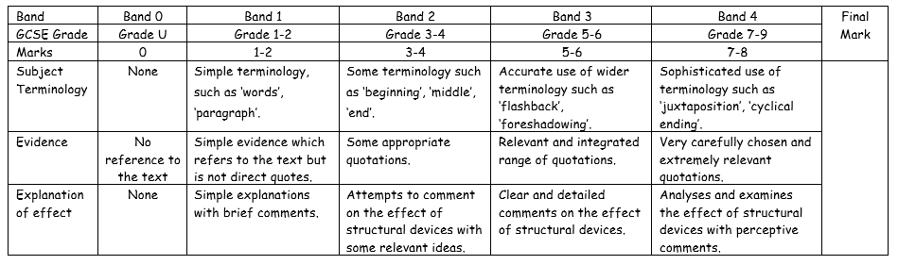

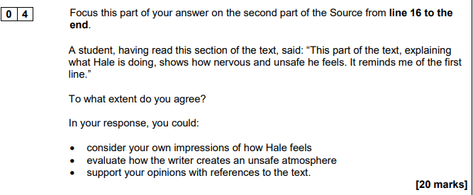
List four things you learn from the whole extract that make you think that Hale feels nervous and unsafe.
Underline evidence in the text for each of these four ideas.
How do these ideas link to the first line of ‘Hale knew, before he had been in Brighton three hours, that they meant to murder him.’
This time, we have to include four features in each of our paragraphs. These are:
- Point that responds to the question – do you agree or disagree that he seems to feel nervous and unsafe?
- Evidence copied from the text and in speech marks
- An explanation of how this shows he feels nervous and unsafe
- An explanation of the language that is used in your evidence to show that he feels nervous and unsafe
Response to statement – do you agree or disagree? | Quote | Explanation of how it shows he is nervous and unsafe | Explanation of how the language shows he is nervous and unsafe.
I agree that Hale seems to feel nervous and unsafe because the writer states that | “There were reasons why he didn't feel too safe in Brighton.” | This suggests that he feels nervous and unsafe because he is not at ease on the streets and he knows that people are after him for whatever reason. | The writer has used the adverb of ‘too’ in this sentence which further suggests he feels nervous and unsafe because it suggests that he doesn’t feel entirely secure and that he might be at under threat, especially as the opening line states that someone meant to murder him.
Furthermore, Hale appears to feel nervous and unsafe when the writer describes | “his bitten nails” | This suggests that he feels nervous and unsafe because | The writer has used the adjective of ‘____________’ in this sentence which further suggests he feels nervous and unsafe because….
In addition, Hale appears to feel nervous and unsafe when the writer describes him as | “alone” | This suggests that he feels nervous and unsafe because | The writer has used the adjective of ‘alone’ in this sentence to further suggest he feels nervous and unsafe because….
However, it could be argued that Hale does not seem nervous and unsafe because | “He leant against the rail near the Palace Pier and showed his face to the crowd.” | This suggests that he does not feel nervous and unsafe because | The writer has used the verb of ‘leant” in this sentence which further suggests he does not feel nervous and unsafe because….

Good example:
I agree with this to a large extent. There many factors from lines 16 downward that tell us or hint at that. I infer that Hale is feeling on edge and uneasy in Brighton - It is due to the fact that he seems to want to get out of every place he is in a quickly as possible. He seem to move on as soon as he is able to. “He drank his gin and tonic Hastily as the clock struck eleven, and moved out of Castle Square -’ shows this. It also shows how anxious and paranoid he could potentially be. This is because he doesn’t seem to trust what he is drinking, this could be as he thinks it could maybe be poisoned.
Hale also comes across as feeling nervous and unsafe as he says “there were reasons why he didn’t feel too safe in Brighton, even in a Whitsun crowd.” This is showing that Hale cannot feel at ease even in a Christian festival environment; He believes that the people who wishes to murder him could still harm him there.
The writer creates a sense of an unsafe atmosphere by cutting a sentence off in the middle. This creates a sense of mystery and danger. ‘...Yesterday Southend, today Brighton, tomorrow - ” This makes it look as there may not be a tomorrow for Hale, As he would be dead. As well as this the sentence is its own paragraph, this makes it seem alone and isolated, much like Hale at that moment. The paragraph that begins after this is a completely different subject, as if Hale’s death would mean very little as he is of little importance to people or as if Hale cannot bear to think about what tomorrow could, or couldn’t, begin.
“the rattle of miniature cars, the ghost train diving between grinning skeletons under the Aquarium promenade…” creates a sense of uneasiness. This is because of the way the writer has described these ordinary things. He has made the seem creepier like objects in the dark and our mind plays tricks on us.
14 marks out of 20

Writing Section
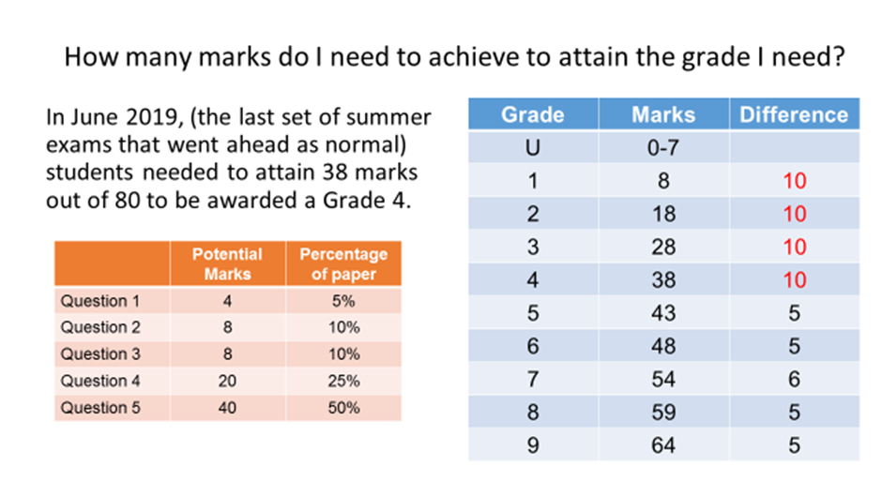
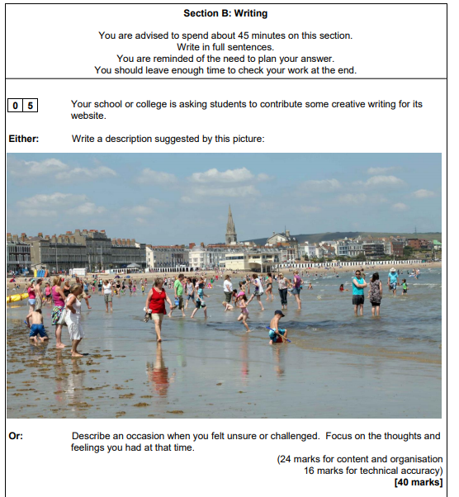

Write a story where someone feels unsafe or nervous.

Here is a story that I have written using the structural devices that we practiced when we were completing question three. It’s not perfect, so I hope you can advise me how to improve it. Give each area above a mark out of 0-4 (4 is the best).
Write a story where someone feels unsafe or nervous.

Pathetic fallacy | Heavy drops of rain fell from the blackening sky above and the wind whipped through the corn in the field. The contrast between the yellow corn and the blue grey sky was stark. Yet all was still, apart from a solitary black crow that eyed the woman with its beady eyes, cawing curiously at her from time to time.
Introduce character | But, ensconced in a flattened clearing in the tall sheaves of corn, Marie grasped at the floor desperately, pain forming her mouth in a cat’s yawn, eyes creased in agony. Her finger tips were bloodied and stained from grabbing at the raw earth for comfort, her clothes ripped and ragged. She moaned in pain, the sound guttural and wild, like an injured animal.
Shift focus to a threat to the character | On the deserted road, behind Marie’s own small car, abandoned haphazardly in her rush for safety, waited, the man wrenched open the doors of his own battered old truck and rummaged amongst the hoard of junk he stored in there: rusty old tools, a stained blanket, the knife. Yes, that was what he was searching for – the knife. The slam of the van doors broke the silence. The crow cawed loudly, hopping nervously from foot to foot.
Shift focus to the characters thoughts | Marie had never felt so alone in her entire life. She thought of her mother at home, no doubt wondering where she was, her husband, who could right now be ringing the police and hospitals, driven mad by the worry of her absence. Yet these thoughts were fleeting, as waves of pain crashed upon her body and again she screamed out in sheer pain.
Flashback | Think, she urged herself, think. Think of survival, think of getting out of here. She suddenly remembered her husband’s smile, his strong arms embracing her, and she forced herself to remember the safety of their home: the floral curtains she had carefully chosen, the soft carpets beneath her feet, the warmth of their bed…
Shift focus to the character’s response to the problem – use long sentences for effect | But then the shadow of the man towered over her again, and Marie screamed as he kneeled before her, the knife glinting against the yellow corn. She screamed, and screamed again, yet it seemed as if this torture would never end, and as he reached out to touch her, his dirt-stained hands calloused and rough, she prayed to God for survival.  The crow cawed ominously and suddenly all was still. The wind rustled amongst the corn.  And then the silence, which hung heavy and low, was eventually broken by the pure and sacred cry of a new-born baby. The man looked into Marie’s eyes and smiled, cradling her child in the stained blanket, and handed him to her gently. She wept. The nightmare was over at last.
- Cyclical ending | Heavy drops of rain fell from the blackening sky above and the wind whipped through the corn in the field. The contrast between the yellow corn and the blue grey sky was stark. Yet all was still, apart from a solitary black crow that eyed the woman with its beady eyes, cawing curiously at her from time to time.

This is a response to the description option. It was awarded 22 marks for composition and effect and 15 marks for technical accuracy. 37 marks = Grade 9
Whooshing waves and squelching sand, the British beach was full of people. The tide was heading out, leaving soaked sand behind. It was perfect to make sand castles out of and many children had fully taken this opportunity (helped by the parents who enjoyed it a little too much). The sea tickled the shore with a foaming wave leaving its mark when it left. Clouds covered much of the sun however the heat was still there and the holiday makers were taking advantage.
One young boy, with blue swimming shorts dug in the sand. His little blue cap protected his face whilst he played in the sun. The smell of suncream radiated off him because his parents didn’t want their son to get burned. The small rippling waves wrapped themselves around his ankles and his face lit up when they splashed against his knees. In his right hand was a blue spade and in his left was a red bucket in which he collected the salty water for the moat around his castle.
Not too far away was a mother dressed in a pink top and floral skirt. She looked towards the sea where her beloved child was playing. As he blonde hair floated in the wind, she wondered when she would get home; her daughter refused to leave the deep, green water. Even though she was only wading in the shallow part, her mother was scared in case she fell and never came back. After countless attempts to remove her child, the woman decided that maybe only the pull of the ice cream van would be enough to get home.
Along the edge of the beach, ran a selection of dull buildings. Many were beach side hotels or B&Bs that were the home of several hundred holiday guests during the summertime. Interrupting the run of accomodation were souvenir shops and eateries. They were dotted at intervals along the coast. Some of the shops sold buckets and spades but many sold gifts for the family back home: fudge and boiled sweets were popular choices. There were many places to eat including: 2 fish and chip shops, 3 ice cream parlours and an italian restaurant. It look very out of place on the cheap and cheerful front. Further away, a big spire arose from behind the buildings. It was dull and full of windows which indicated that it was a church or cathedral - Maybe a visitor attraction.
The beach was alive with people and colour, the swimwear had a vast range of tones. From light to dark, bright to dull, this beach had it all. Many of the children were wearing trunks or swimming costumes but the adults decided to keep their modesty because the howling wind had quite a bite.
Overall, the guest were definitely enjoying their day, even if there was a wet t-shirt or two. The smell of suncream and salt; the sound of giggles and snores and the sights of the beach, are all part of a good day out.

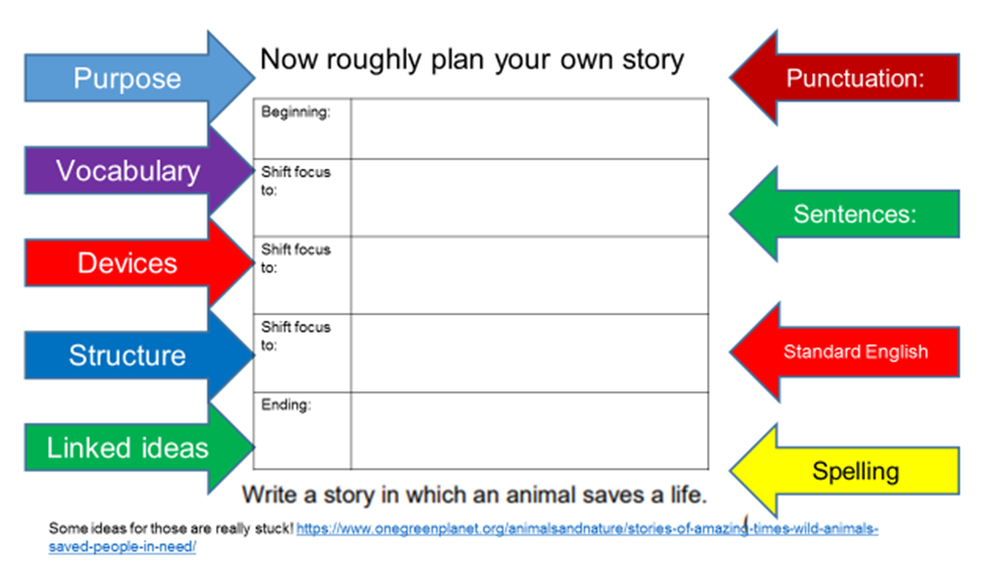
You could choose to write a story or you could choose to write a description. Make sure that you aim to build an atmosphere in your writing.
Write a description suggested by the Brighton beach photograph
Or
Write a story where someone feels unsafe or nervous.
[Grab your reader’s attention with a great quote from the document or use this space to emphasize a key point. To place this text box anywhere on the page, just drag it.]

